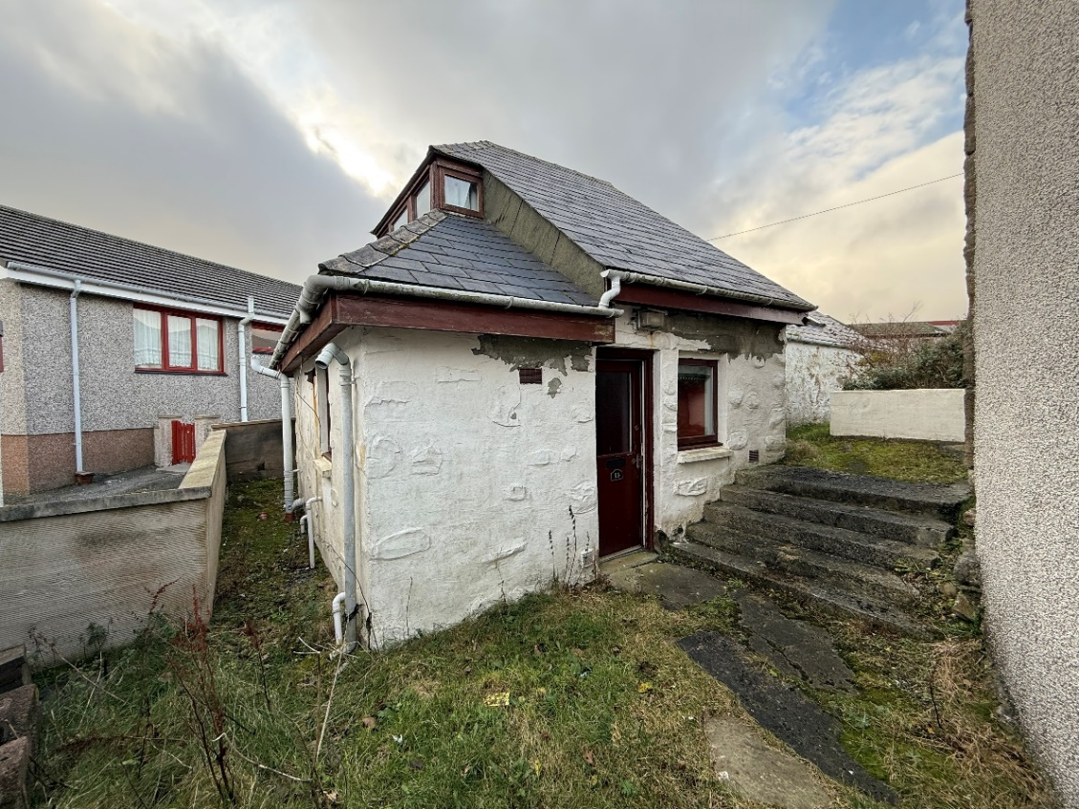

13 KANTERSTED ROAD, LERWICK

Development opportunity: - This detached two bedroomed house in very poor condition requires major renovation on a restricted site. Reroofing is required and valuation commentary details many defects. There is no central heating and electrical installation requires upgrading/rewiring. The interior requires total refurbishment. No Home Report in view of the condition of the property. Energy Performance Certificate is available. The benefits in remodeling gives scope to plan a dream home as an exciting venture to express individuality and style. Shared pedestrian access.

EPC RATING Band G (17)

OFFERS Offers over £55,000

VIEWING Contact our Reception

